Order Of Service

Singing: Psalm 65—CW page 89

Reading: Psalm 78:65-72

Opening Hymn: TLH 318

Reading: Acts 12:20-25

Request Hymn: CW Supplement 705

Reading: Matthew 1:1-17

Sermon Hymn: TLH 325

Sermon Text: Mark 1:04-08

Repent!

Prayer

The Apostles’ Creed, TLH page 12

Holy Communion

The Lord's Prayer

The Blessing

Closing Hymn: TLH 330

* * * * * * * * * * *

Koinonia Hour

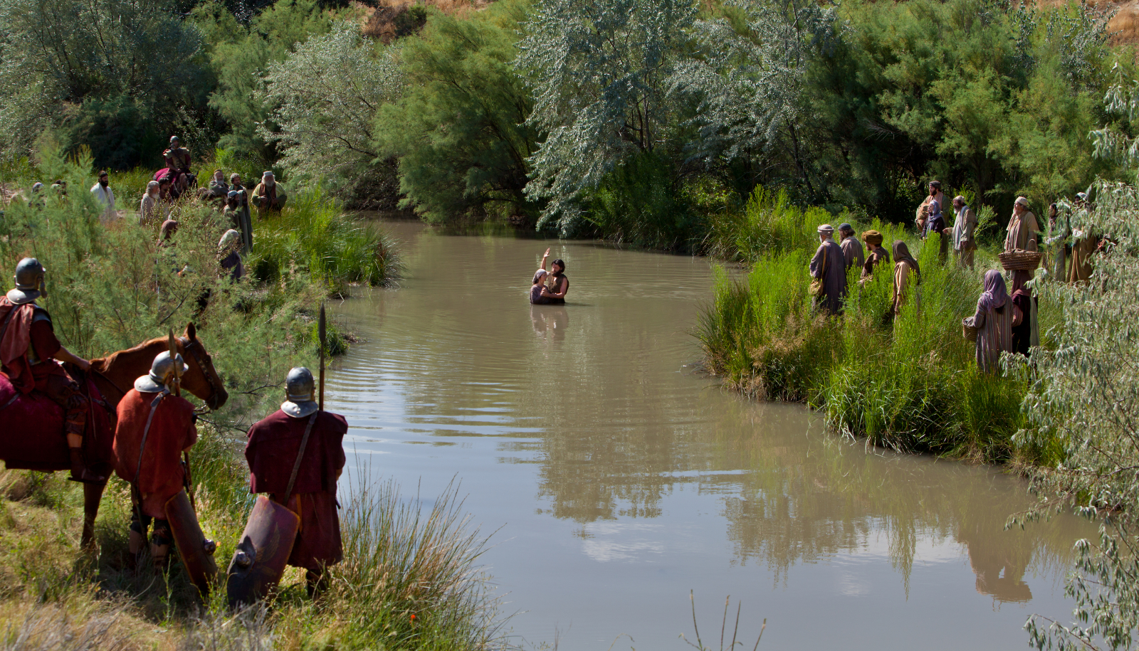

John Baptizing In Jordan

Water
Of
Life

2 September 2018

W A T E R O F L I F E

Independent Christian Church—Conservative Lutheran Doctrine

Worship Service: 9:30 a.m. Bible Study: 10:45 a.m.

Larry Cooper, Pastor E-Mail address:
111 N. Ridge Road lcooper@wateroflife.cc
Coon Valley, WI 54623 Web Site:
Phone: (608) 452-2105 www.wateroflife.cc

* * * * * * * * * * * * * * * * * * * * * * * * * * *

Sermon Text: Mark 1:04-08

Repent!

* * * * * * * * * * * * * * * * * * * * * * * * * * *

Mark 1:4 John did baptize in the wilderness, and preach the baptism of repentance for the remission of sins.
:5 And there went out unto him all the land of Judaea, and they of Jerusalem, and were all baptized of him in the river of Jordan, confessing their sins.
:6 And John was clothed with camel's hair, and with a girdle of a skin about his loins; and he did eat locusts and wild honey;
:7 And preached, saying, There cometh one mightier than I after me, the latchet of whose shoes I am not worthy to stoop down and unloose.
:8 I indeed have baptized you with water: but he shall baptize you with the Holy Ghost.
Malachi 4:5: Behold, I will send you Elijah the prophet before the coming of the great and dreadful day of the LORD:

Mark 9:11-13 11: And they asked him, saying, Why say the scribes that Elias must first come?
12: And he answered and told them, Elias verily cometh first, and restoreth all things; and how it is written of the Son of man, that he must suffer many things, and be set at nought.
13: But I say unto you, That Elias is indeed come, and they have done unto him whatsoever they listed, as it is written of him.

Luke 1:17 And he shall go before him in the spirit and power of Elias, to turn the hearts of the fathers to the children, and the disobedient to the wisdom of the just; to make ready a people prepared for the Lord.

Matthew 3:1-5 1: In those days came John the Baptist, preaching in the wilderness of Judaea,
2: And saying, Repent ye: for the kingdom of heaven is at hand.
3: For this is he that was spoken of by the prophet Esaias, saying, The voice of one crying in the wilderness, Prepare ye the way of the Lord, make his paths straight.
4: And the same John had his raiment of camel's hair, and a leathern girdle about his loins; and his meat was locusts and wild honey.
5: Then went out to him Jerusalem, and all Judaea, and all the region round about Jordan,

Matthew 17:11-13 11: And Jesus answered and said unto them, Elias truly shall first come, and restore all things.
12: But I say unto you, That Elias is come already, and they knew him not, but have done unto him whatsoever they listed. Likewise shall also the Son of man suffer of them.
13: Then the disciples understood that he spake unto them of John the Baptist.

